

MAHATMA EDUCATION SOCIETY’S
PILLAI COLLEGE OF ARTS, COMMERCE & SCIENCE
(Autonomous)
NEW PANVEL

PROJECT REPORT ON:-
“YATRIK – RAILWAY TICKET BOOKING SYSTEM”

IN PARTIAL FULFILLMENT OF:-
BACHELOR OF COMPUTER APPLICATIONS
SEMESTER III – 2026-27

PROJECT GUIDE:-
Anuradha Singh

SUBMITTED BY:-
KUNAL V. SHINDE
ROLL NO: 4957

Yatrik:- Ticket Booking System
- Abstract
Yatrik is a simple Railway Ticket Booking System developed to demonstrate the practical use of a Database Management System. The project allows users to register and log in, search for available trains, book railway tickets, view their bookings and cancel tickets.
The system uses Python and Tkinter for the graphical user interface and Oracle Database 21c XE for storing and managing data. The database consists of four main tables: USERS, STATIONS, TRAINS, and BOOKINGS. Primary keys, foreign keys, unique constraints and SQL operations are used to maintain data integrity.
The project demonstrates how a DBMS can be used to store, retrieve, update and manage railway reservation information efficiently.
- Introduction
Railway reservation systems handle a large amount of information such as passenger details, train information, railway stations and ticket bookings. Managing this information manually can be difficult and may lead to data duplication and errors.
Yatrik is developed as a basic railway ticket booking system using database concepts. It provides a simple interface through which users can register, log in, search for trains and book or cancel tickets.
The main database contains four tables:
- USERS – stores registered user information.
- STATIONS – stores railway station information.
- TRAINS – stores train details, routes, fares and available seats.
- BOOKINGS – stores passenger and ticket booking information.
The project focuses mainly on the application of DBMS concepts such as tables, constraints, relationships, SQL queries, normalization and data integrity.

- Objectives

The main objectives of Yatrik are:
- To develop a simple and user-friendly Railway Ticket Booking System.
- To store and manage user, station, train and booking information using Oracle Database 21c XE.
- To allow users to register and log in securely.
- To provide train searching based on source and destination stations.
- To allow users to book and cancel railway tickets.
- To automatically generate a unique PNR number for each booking.
- To maintain available seat information after booking and cancellation.
- To implement important DBMS concepts such as primary keys, foreign keys, unique constraints, normalization and SQL queries.
- To demonstrate the practical use of Python with Oracle Database in a real-world application.
- The Tkinter creates the python app in which the system runs.
- Technologies Use
Technology | Purpose
Python | Development of the application
Tkinter | Creation of the graphical user interface
tkcalendar | Provides the calendar for selecting journey dates
SQL*Plus | Creating and managing database objects and executing queries
oracledb | Connects the Python application with Oracle Database

Python
Python is used to develop the main application logic and connect the user interface with the database.

Tkinter
Tkinter is used to create the graphical interface of Yatrik, including login, registration, train search, booking and booking-management screens.

SQL*Plus
SQL*Plus is used to execute SQL commands and demonstrate database operations.

Tkcalendar
The tkcalendar library provides a calendar-based date selection component for choosing the journey date.
- ER Diagram
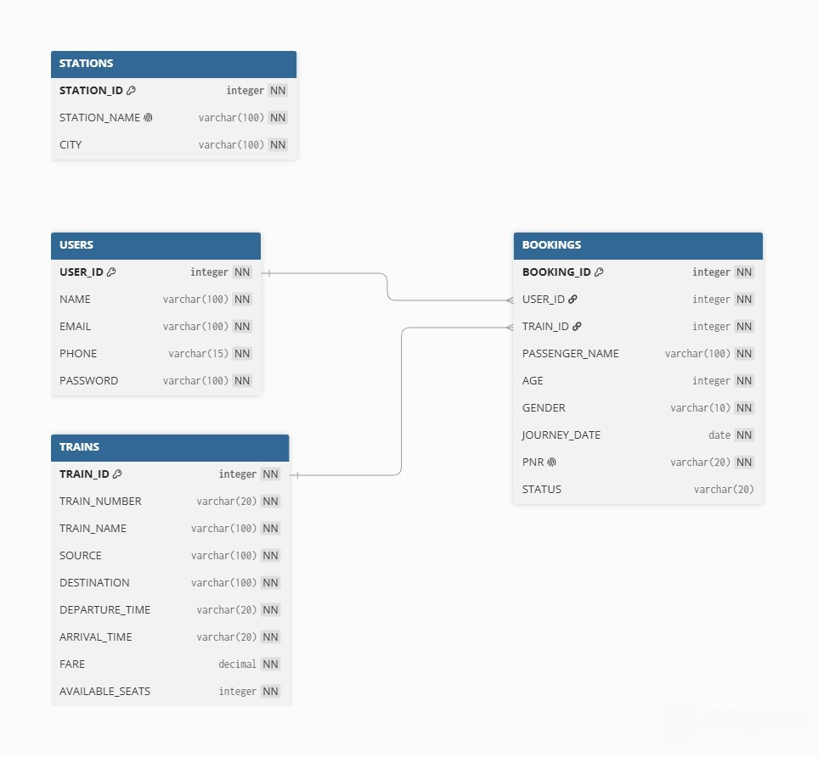

- Normalization
Normalization is the process of organizing data in a database to reduce data redundancy and improve data integrity.
Yatrik uses separate tables for users, stations, trains and bookings, which helps avoid unnecessary duplication.

First Normal Form – 1NF
A table is in 1NF when each column contains atomic values and there are no repeating groups.
The Yatrik tables contain individual values in each field. For example, the USERS table stores one name, email and phone number for each user.
Therefore, the tables follow 1NF.

Second Normal Form – 2NF
A table is in 2NF when it is in 1NF and all non-key attributes depend completely on the primary key.
In Yatrik, information is divided into separate tables. For example, train information is stored in TRAINS rather than repeatedly storing train details in every booking.
Therefore, the database follows the principles of 2NF.

Third Normal Form – 3NF
A table is in 3NF when it is in 2NF and non-key attributes do not depend on other non-key attributes.
Yatrik separates different types of information into different tables:
USERS → User information
STATIONS → Station information
TRAINS → Train information
BOOKINGS → Booking information
This reduces unnecessary duplication and avoids transitive dependencies.
Therefore, the database is designed according to 3NF principles.
- Screenshots

7.1 Yatrik Home Screen
Description:
The home screen provides access to train search, login and registration options.
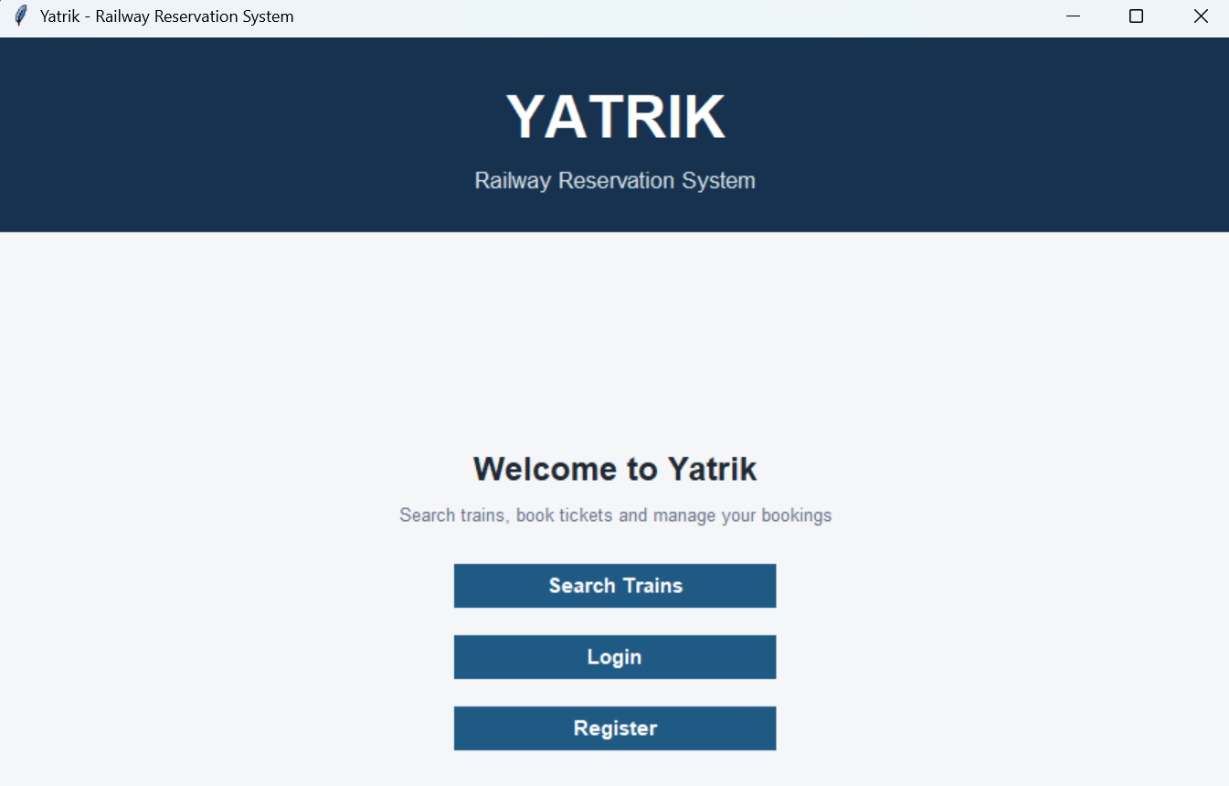

7.2 User Registration and Login
Description:
The registration and login screens demonstrate user authentication and the storage of user information in the USERS table.

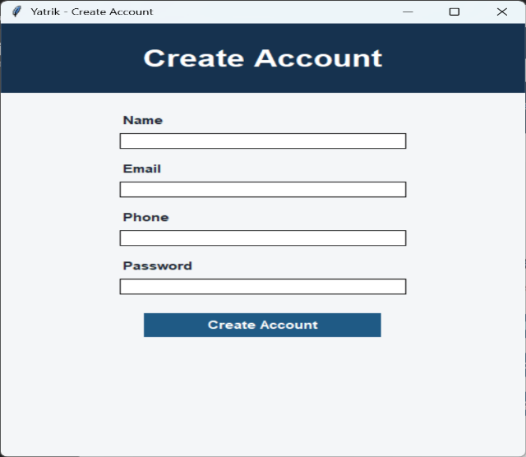
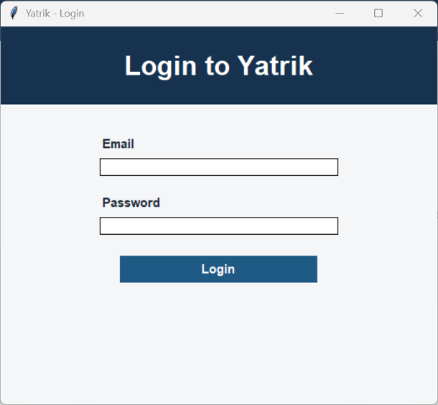

7.3 Train Search
Description:
Users can select the source and destination stations to search for available trains stored in the TRAINS table.

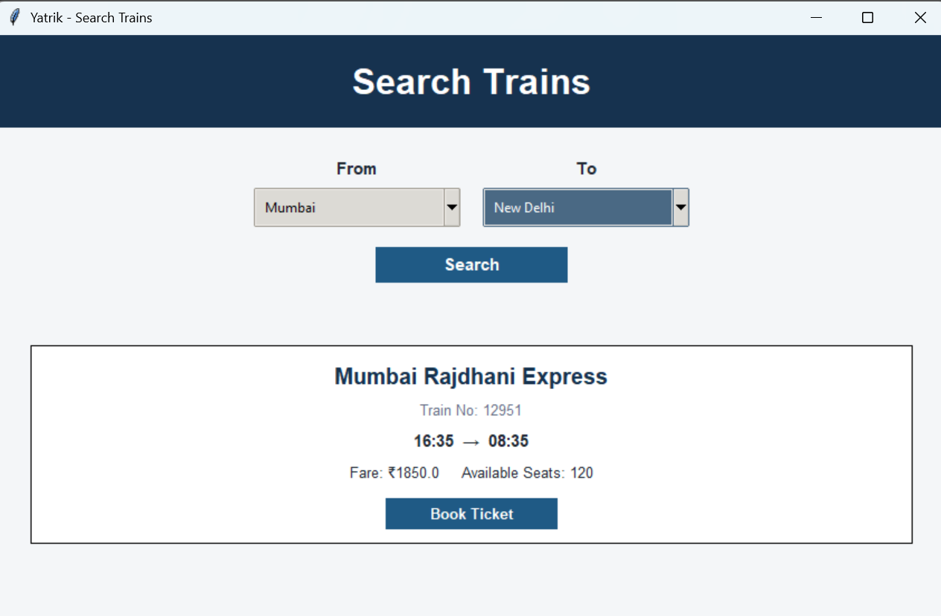

7.4 Book Ticket
Description:
The booking screen collects passenger details and journey date. The booking information is stored in the BOOKINGS table.

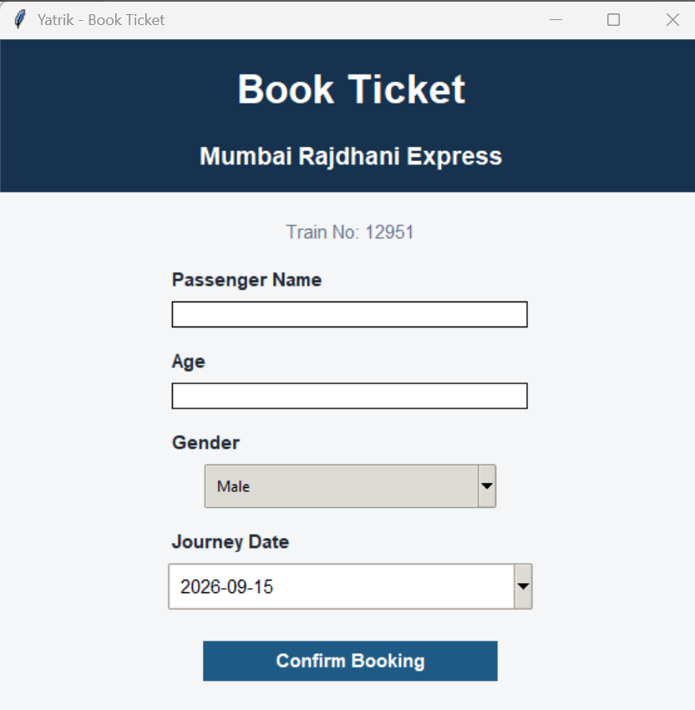

7.5 My Bookings and Cancellation
Description:
Users can view their bookings and cancel a confirmed ticket. The booking status and available seat count are updated in the database.

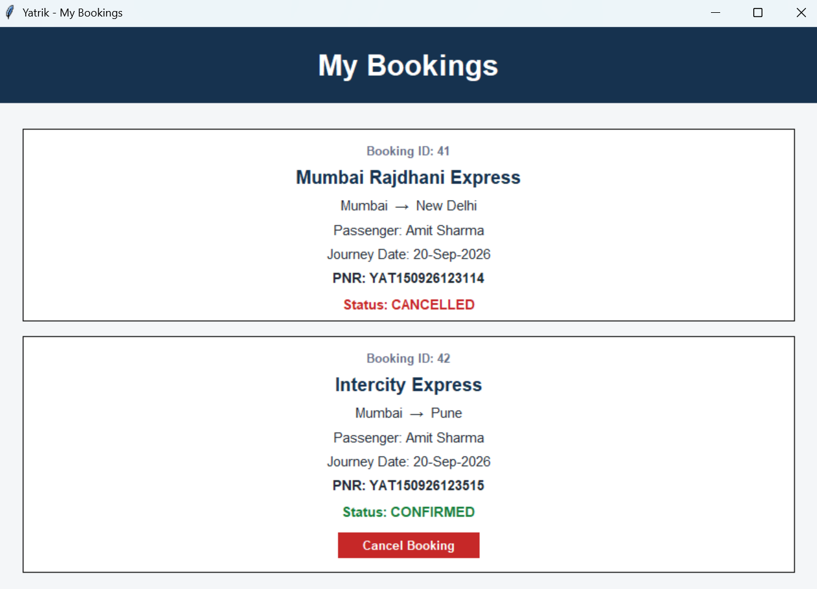

7.6 Database Tables and Constraints
Description:
This screenshot shows the creation of the USERS, STATIONS, TRAINS and BOOKINGS tables in Oracle using SQL/SQL*Plus, including primary key, foreign key, unique and NOT NULL constraints.

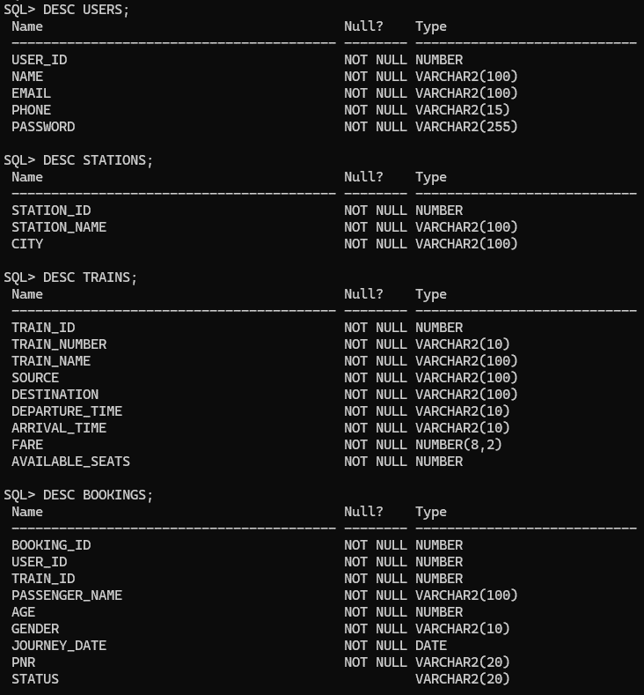

7.7 Database Records
Description:
This screenshot shows sample records stored in the Yatrik database using SELECT queries. It demonstrates how user, station, train and booking data are stored and retrieved.
- USERS TABLE

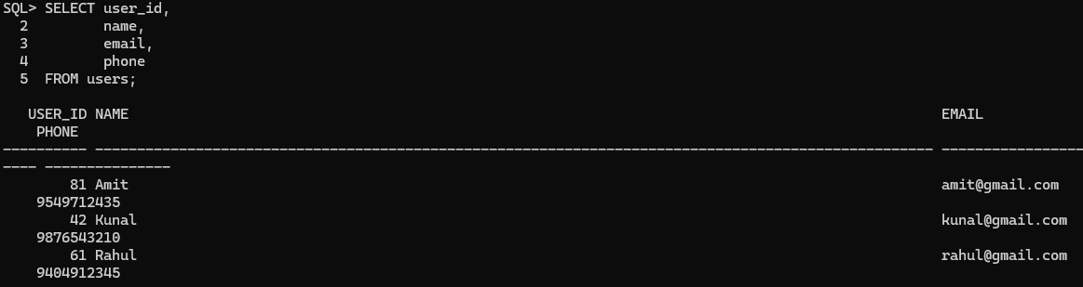
- STATIONS TABLE

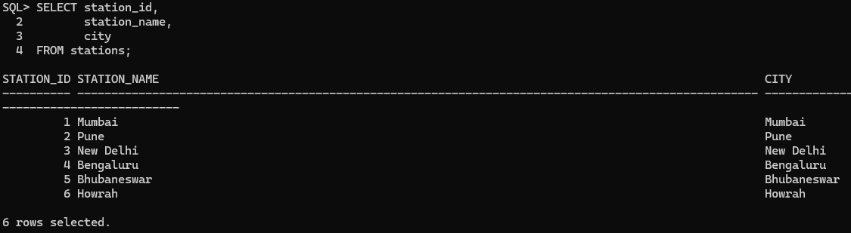

- TRAINS TABLE

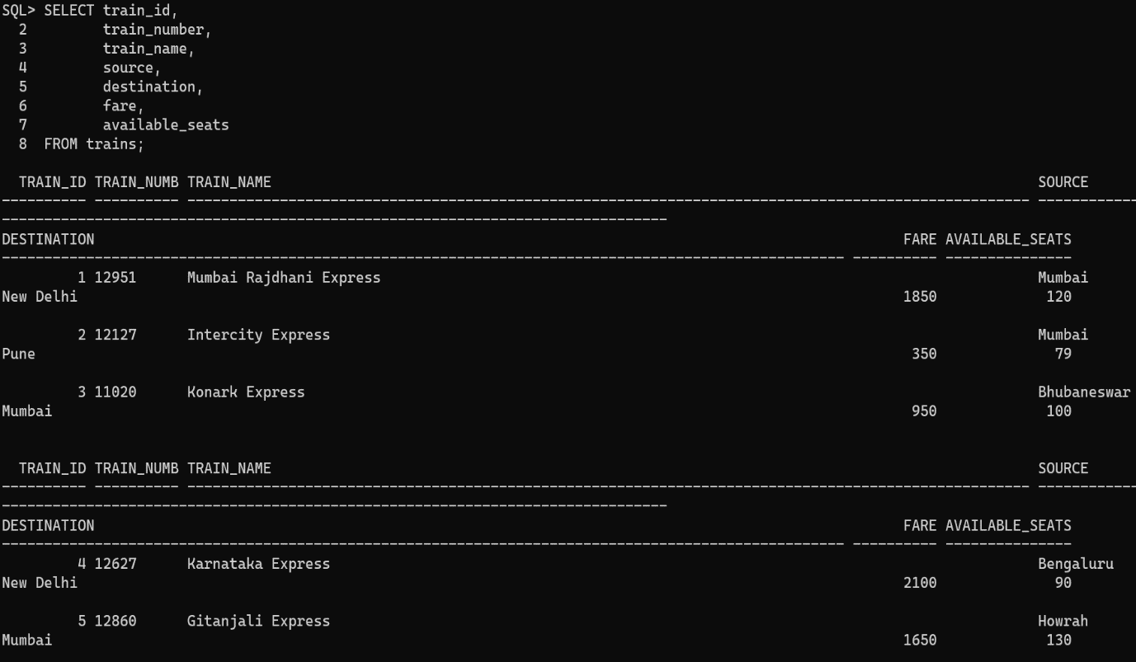
- BOOKINGS TABLE

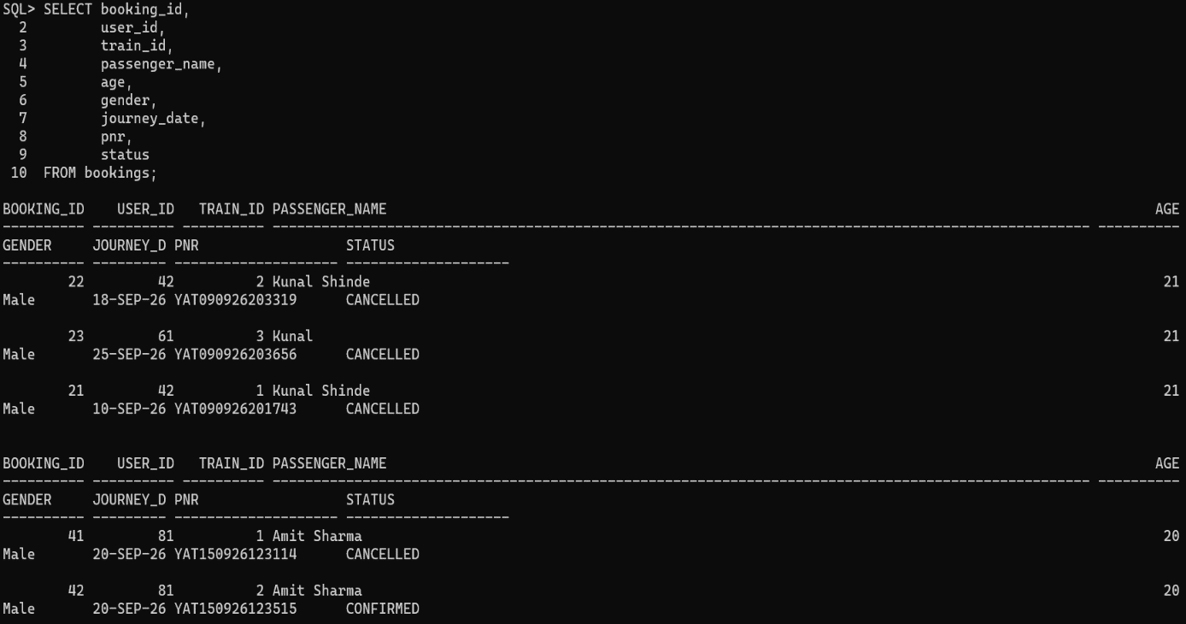

7.8 SQL Join Query
Description:
This screenshot demonstrates a JOIN query between the BOOKINGS and TRAINS tables to display booking details along with train information.
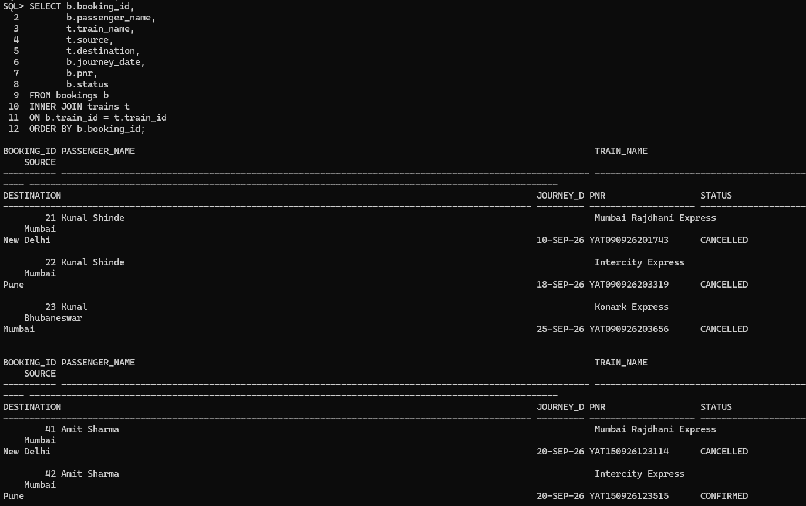

7.9 Aggregate and GROUP BY Query
Description:
This screenshot demonstrates the use of SQL aggregate functions and GROUP BY to analyze booking data.
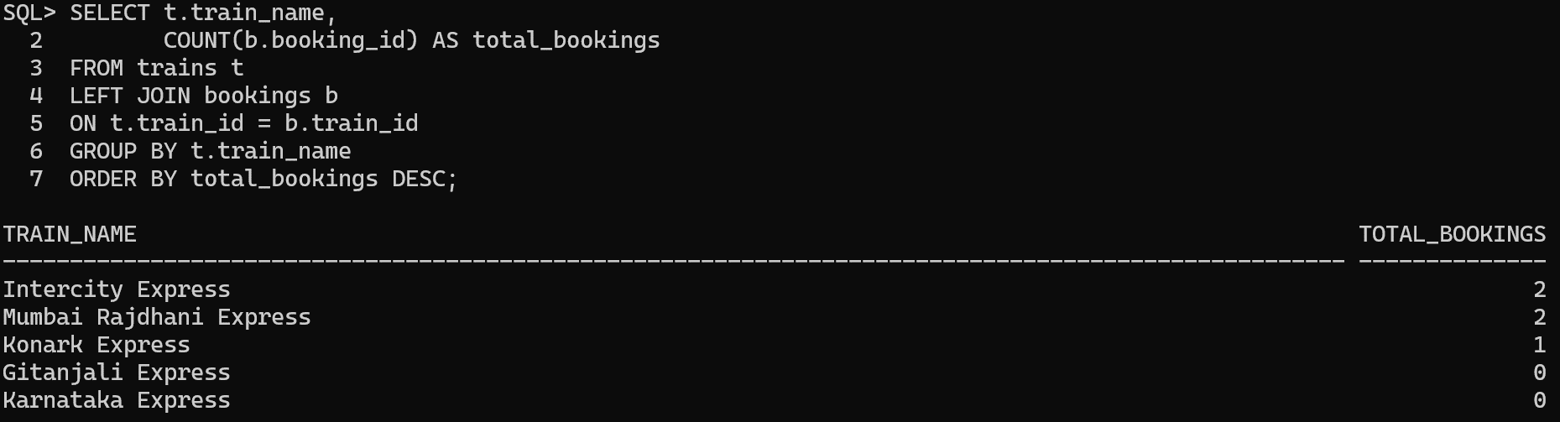

7.10 View / Normalized Database
Description:
This screenshot demonstrates a database view created from the Yatrik tables. It shows how database objects can be used to simplify data retrieval while maintaining a structured and normalized database design.
- CREATING A VIEW
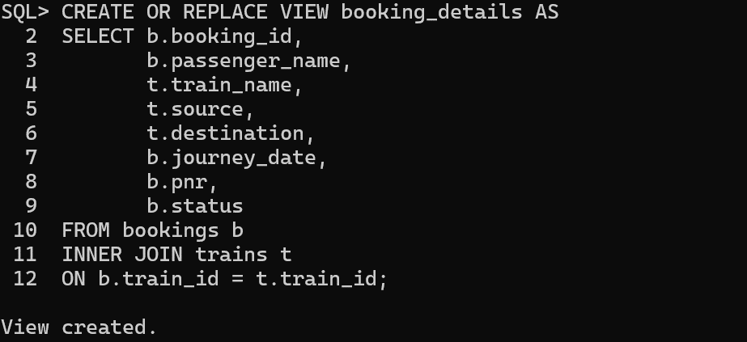
- VIEWING A VIEW
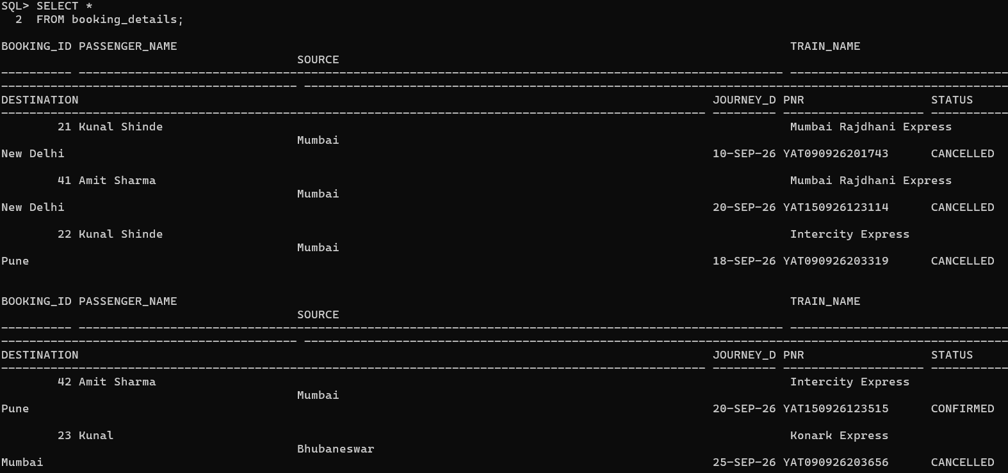

- SWOT ANALYSIS

Strengths (S) | Weaknesses (W)
- Simple and user-friendly interface  - Uses Oracle Database for structured data storage  - Uses primary and foreign key constraints  - Supports booking and cancellation | - Limited booking functionality  - No online payment system  - No administrator dashboard  - Currently supports basic passenger booking
Opportunities (O) | Threats (T)
- Online payment integration  - Seat selection functionality  - Admin dashboard  - Real-time train information | - Unauthorized access  - Data security risks  - Data loss without proper backup  - Incorrect user input

- Future Scope
The Yatrik system can be improved in the future by adding:
- Online payment for ticket booking.
- Seat selection for passengers.
- Multiple passengers in a single booking.
- Admin dashboard for managing trains and stations.
- Train schedule management.
- Email or SMS notifications for booking confirmation.
- Real-time train status and availability.

Conclusion
Yatrik successfully demonstrates the practical implementation of Database Management System concepts through a Railway Ticket Booking System. The project uses Oracle Database 21c XE to efficiently store, organize and manage important information related to users, stations, trains and bookings.
The system implements essential database concepts such as tables, primary keys, foreign keys, unique constraints, normalization and SQL operations to maintain structured and reliable data. The Python Tkinter interface provides a simple and user-friendly way to perform operations such as user registration, login, train search, ticket booking, viewing bookings and cancellation.
The project also demonstrates how database relationships and SQL queries can be used to retrieve and update information efficiently. Overall, Yatrik provides a practical real-world application of DBMS concepts and shows how a well-structured database can be integrated with a simple application to manage railway ticket reservations effectively.

